Transformation About a Center

Definition
# Source: AI Source: Provided by: [Data Path: Persons Table -> ID Column: 1, Name_En Column: Motasem Essam] -> From: [ChatGPT] on [7/25/2026]
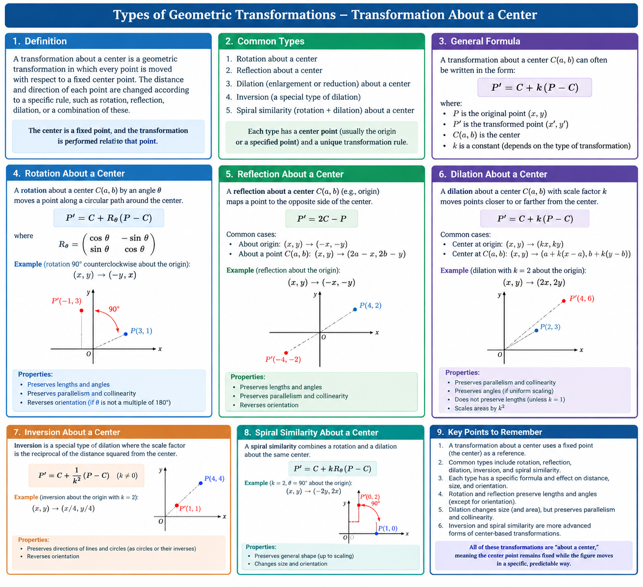
A Transformation About a Center is a geometric transformation defined relative to a fixed point called the center of transformation. The center serves as a reference point around which points or figures are moved, rotated, reflected through, or scaled, depending on the transformation.
Let $O$ be the center and PPP an original point. After transformation, $P$ maps to $P'$.
Different transformations use the center in different ways:
- Rotation: turns a point around the center.
- Dilation: moves a point toward or away from the center according to a scale factor.
- Central reflection: maps a point to the opposite side of the center at the same distance.
- Homothety: scales a figure relative to a fixed center.

Simple Definition
# Source: AI Source: Provided by: [Data Path: Persons Table -> ID Column: 1, Name_En Column: Motasem Essam] -> From: [ChatGPT] on [7/25/2026]
A transformation about a center is a geometric transformation that uses a fixed point as the reference for moving or mapping other points.
Important distinction: “Transformation about a center” is a broad descriptive category, not one single transformation with one universal formula. The exact rule depends on the transformation type.

Main Classification
# Source: AI Source: Provided by: [Data Path: Persons Table -> ID Column: 1, Name_En Column: Motasem Essam] -> From: [ChatGPT] on [7/25/2026]
A practical classification of transformations defined relative to a center is:
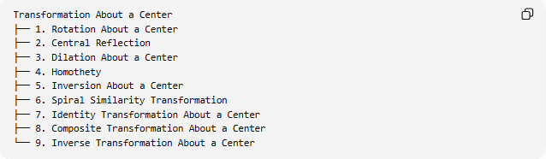
Transformation About a Center
├── 1. Rotation About a Center
├── 2. Central Reflection
├── 3. Dilation About a Center
├── 4. Homothety
├── 5. Inversion About a Center
├── 6. Spiral Similarity Transformation
├── 7. Identity Transformation About a Center
├── 8. Composite Transformation About a Center
└── 9. Inverse Transformation About a Center
These types are not all members of the same formal classification. Rotation, central reflection, and dilation are common elementary examples; inversion is a distinct transformation from circle geometry; the remaining entries describe related or combined cases.

Rotation About a Center
# Source: AI Source: Provided by: [Data Path: Persons Table -> ID Column: 1, Name_En Column: Motasem Essam] -> From: [ChatGPT] on [7/25/2026]
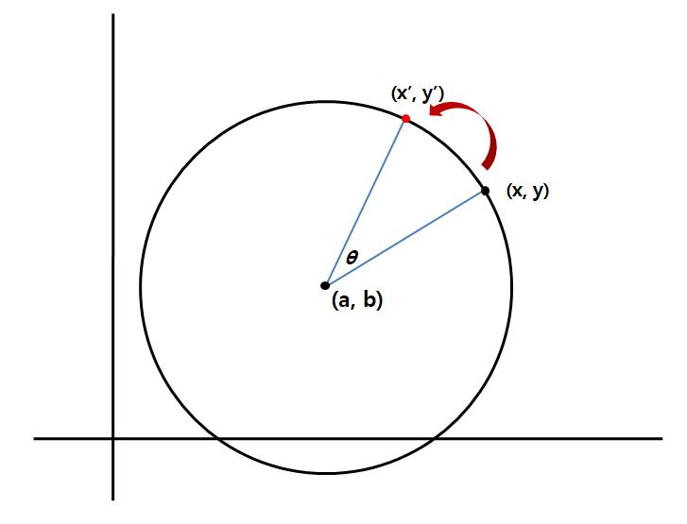
Definition: A rotation about a center turns a point or figure through an angle $θ$ while keeping the center fixed.
For a center $C=\left(a,b\right)$, a point $P=\left(x,y\right)$ transforms according to:
$$x'​=a+\left(x-a\right)cosθ-\left(y-b\right)sinθ$$
$y'=b+\left(x-a\right)sinθ+\left(y-b\right)cosθ$​
Example: Rotate $P=\left(3,1\right)$ by $90∘$ counterclockwise about the origin.
$$\left(x,y\right)→\left(-y,x\right)$$
Therefore:
$$\boxed{P'=\left(-1,3\right)}$$
Properties:
- Preserves lengths and angle measures.
- Preserves parallelism and collinearity.
- Keeps the center fixed.
- Reversing the rotation requires angle −θ-\theta−θ.

Central Reflection
# Source: AI Source: Provided by: [Data Path: Persons Table -> ID Column: 1, Name_En Column: Motasem Essam] -> From: [ChatGPT] on [7/25/2026]
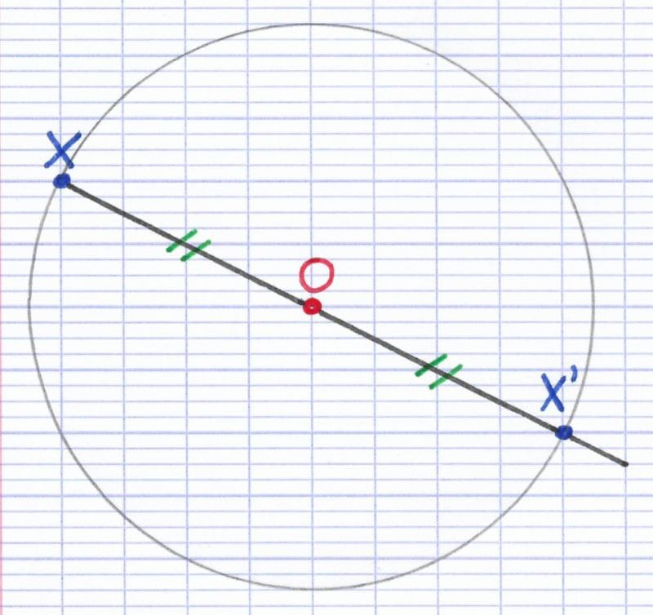
Definition: Central reflection maps a point to the opposite side of a fixed center, at the same distance from that center. It is equivalent to a ${180}^{∘}$ rotation.
For center $C=\left(a,b\right)$:
$$\boxed{x'=2a-x, y'=2b-y}$$
Example: Reflect $P=\left(2,3\right)$ through the origin.
$$\left(x,y\right)→\left(-x,-y\right)$$
Thus:
$$\boxed{P'=\left(-2,-3\right)}$$
Properties:
- Preserves lengths and angles.
- Reverses each point's position relative to the center.
- The center is the midpoint of $PP'$.
- Applying it twice returns the original figure.
Terminology: Central reflection is also called point reflection or point symmetry.

Dilation About a Center
# Source: AI Source: Provided by: [Data Path: Persons Table -> ID Column: 1, Name_En Column: Motasem Essam] -> From: [ChatGPT] on [7/25/2026]
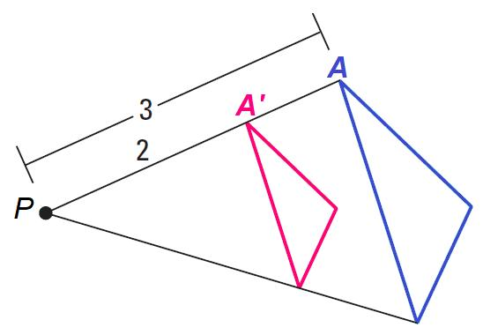
Definition: A dilation enlarges or reduces a figure relative to a fixed center using a scale factor $k$.
For center $C=\left(a,b\right)$:
$$\boxed{\begin{aligned}x^{'}&=a+k\left(x-a\right) \\ y^{'}&=b+k\left(y-b\right)\end{aligned}}$$
Equivalently, in vector notation:
$$\boxed{P'=C+k\left(P-C\right)}$$
Example: Dilate $P=\left(2,3\right)$ by factor $k=2$ about the origin.
$$\left(x,y\right)→\left(2x,2y\right)$$
Therefore:
$$\boxed{P'=\left(4,6\right)}$$
Properties:
- Preserves straightness and parallelism.
- Preserves angles for ordinary positive or negative nonzero uniform scale factors.
- Multiplies lengths by $\left|k\right|$.
- Multiplies areas by $k^{2}$.
- For $k=1$, the transformation is the identity.
- For $k=0$, all points collapse to the center, so the transformation is not invertible.

Homothety
# Source: AI Source: Provided by: [Data Path: Persons Table -> ID Column: 1, Name_En Column: Motasem Essam] -> From: [ChatGPT] on [7/25/2026]
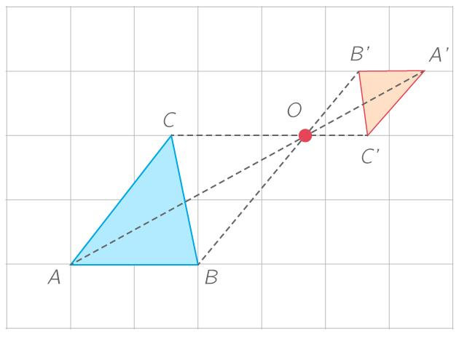
Definition: A homothety is a dilation with a fixed center. It maps each point along the line through the center and that point.
Its formula is:
$$\boxed{P'=C+k\left(P-C\right)}$$
Example: Let the center be $C=\left(1,1\right)$, the point be $P=\left(3,2\right)$, and $k=3$.
$$P'=\left(1,1\right)+3\left(\left(3,2\right)-\left(1,1\right)\right)$$
$$\boxed{P'=\left(7,4\right)}$$
Properties:
- Preserves collinearity and parallelism.
- Preserves ratios along lines.
- Produces a similar figure.
- A negative scale factor places the image on the opposite side of the center.
Relationship: In elementary Euclidean geometry, homothety is the standard name for a center-based dilation.

Inversion About a Center
# Source: AI Source: Provided by: [Data Path: Persons Table -> ID Column: 1, Name_En Column: Motasem Essam] -> From: [ChatGPT] on [7/25/2026]
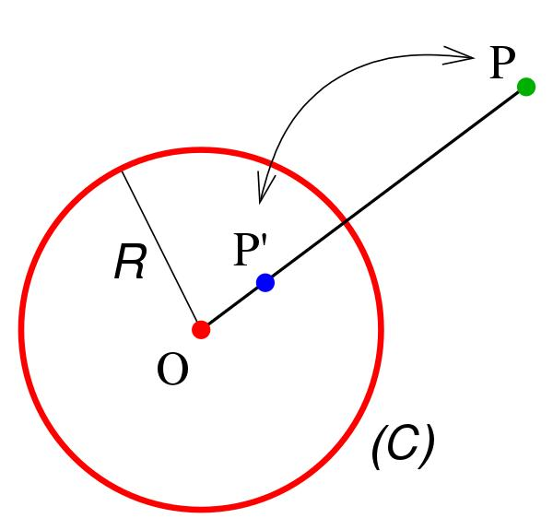
Definition: Inversion about a center $O$, with inversion radius $r$, maps a point $P≠O$ to a point $P'$ on the same ray such that:
$$\boxed{OP⋅OP'=r^{2}}$$
Consequently:
$$\boxed{OP'=\frac{r^{2}}{OP}}$$
Example: Let $r=4$ and $OP=8$.
$$OP'=\frac{4^{2}}{8}=\frac{16}{8}=2$$
The image lies 2 units from the center along the same ray.
Properties:
- Points inside the inversion circle map outside it, and vice versa.
- Points on the inversion circle remain fixed.
- Inversion is self-inverse.
- Lines and circles map to lines or circles, with cases depending on whether they pass through the center.
Important distinction: Inversion is not the same as ordinary dilation. Its scale depends on the point's distance from the center.

Spiral Similarity Transformation
# Source: AI Source: Provided by: [Data Path: Persons Table -> ID Column: 1, Name_En Column: Motasem Essam] -> From: [ChatGPT] on [7/25/2026]
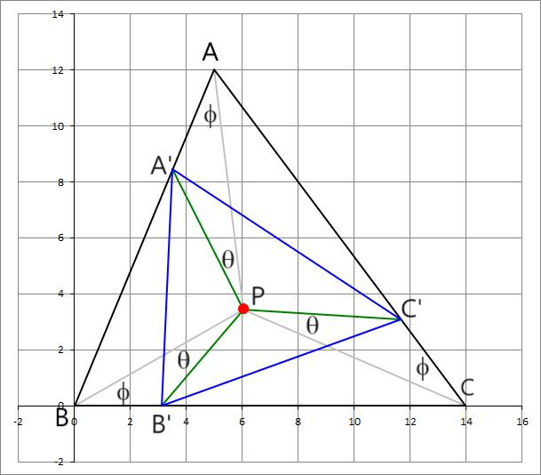
Definition: A spiral similarity combines a rotation about a center with a dilation about the same center.
Its vector formula is:
$$\boxed{P^{'}=C+kR_{θ}\left(P-C\right)}$$
where $R_{θ}$denotes rotation by angle $θ$.
Example: Rotate $P=\left(1 , 0\right)$by ${90}^{∘}$counterclockwise and then scale by $k=2$about the origin.
First:
$$\left(1 , 0\right)→\left(0 , 1\right)$$
Then:
$$\left(0 , 1\right)→\left(0 , 2\right)$$
Therefore:
$$\boxed{P^{'}=\left(0 , 2\right)}$$
Properties:
- Preserves angles.
- Scales all lengths by $∣k∣$.
- Preserves parallelism.
- Combines rotation and uniform scaling in one transformation.

Identity Transformation About a Center
# Source: AI Source: Provided by: [Data Path: Persons Table -> ID Column: 1, Name_En Column: Motasem Essam] -> From: [ChatGPT] on [7/25/2026]
Definition: The identity transformation leaves every point unchanged, including the center.
$$\boxed{T\left(P\right)=P}$$
For a center-based dilation, this corresponds to $k=1$. For a rotation, it corresponds to a full turn such as ${360}^{∘}$.
Example:
$$P=\left(4 , 7\right)→P^{'}=\left(4 , 7\right)$$
No point moves.

Composite Transformation About a Center
# Source: AI Source: Provided by: [Data Path: Persons Table -> ID Column: 1, Name_En Column: Motasem Essam] -> From: [ChatGPT] on [7/25/2026]
Definition: A composite transformation combines two or more transformations, often using the same center.
For example:
$$T=R_{θ}∘D_{k}$$
This means apply dilation first, then rotation.
If both transformations share center $C$, the result can be represented as a spiral similarity:
$$P^{'}=C+kR_{θ}\left(P-C\right)$$
Example: Dilate a point by factor $3$, then rotate it ${90}^{∘}$counterclockwise about the origin.
For $P=\left(1 , 2\right)$:
$$\left(1 , 2\right)→\left(3 , 6\right)$$
Then:
$$\left(3 , 6\right)→\left(-6 , 3\right)$$
Therefore:
$$\boxed{P^{'}=\left(-6 , 3\right)}$$

Inverse Transformation About a Center
# Source: AI Source: Provided by: [Data Path: Persons Table -> ID Column: 1, Name_En Column: Motasem Essam] -> From: [ChatGPT] on [7/25/2026]
An inverse transformation reverses the original transformation.
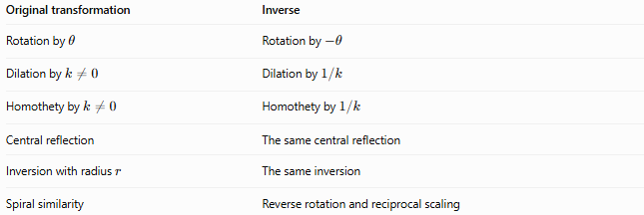
Original transformation | Inverse
Rotation by $θ$ | Rotation by $-θ$
Dilation by $k≠0$ | Dilation by $1/k$
Homothety by $k≠0$ | Homothety by $1/k$
Central reflection | The same central reflection
Inversion with radius $r$ | The same inversion
Spiral similarity | Reverse rotation and reciprocal scaling
For a dilation:
$$P^{'}=C+k\left(P-C\right)$$
the inverse is:
$$\boxed{P=C+\frac{1}{k}\left(P^{'}-C\right)}$$
provided $k≠0$.

Comparison of Center-Based Transformations
# Source: AI Source: Provided by: [Data Path: Persons Table -> ID Column: 1, Name_En Column: Motasem Essam] -> From: [ChatGPT] on [7/25/2026]
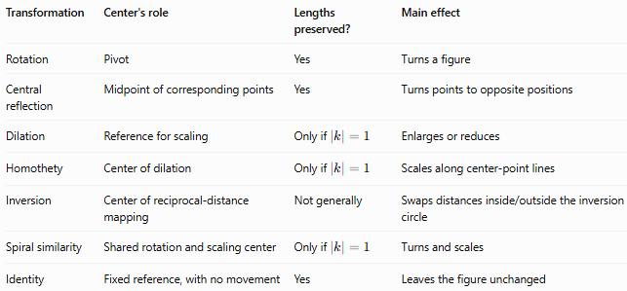
Transformation | Center's role | Lengths preserved? | Main effect
Rotation | Pivot | Yes | Turns a figure
Central reflection | Midpoint of corresponding points | Yes | Turns points to opposite positions
Dilation | Reference for scaling | Only if $∣k∣=1$ | Enlarges or reduces
Homothety | Center of dilation | Only if $∣k∣=1$ | Scales along center-point lines
Inversion | Center of reciprocal-distance mapping | Not generally | Swaps distances inside/outside the inversion circle
Spiral similarity | Shared rotation and scaling center | Only if $∣k∣=1$ | Turns and scales
Identity | Fixed reference, with no movement | Yes | Leaves the figure unchanged

Key Formulas
# Source: AI Source: Provided by: [Data Path: Persons Table -> ID Column: 1, Name_En Column: Motasem Essam] -> From: [ChatGPT] on [7/25/2026]
General center-based dilation:
$$\boxed{P^{'}=C+k\left(P-C\right)}$$
Rotation about $C=\left(a , b\right)$:
$$\boxed{\begin{aligned}x^{'}&=a+\left(x-a\right)\cos{θ}-\left(y-b\right)\sin{θ} \\ y^{'}&=b+\left(x-a\right)\sin{θ}+\left(y-b\right)\cos{θ}\end{aligned}}$$
Central reflection:
$$\boxed{P^{'}=2C-P}$$
Inversion:
$$\boxed{OP⋅OP^{'}=r^{2}}$$
Spiral similarity:
$$\boxed{P^{'}=C+kR_{θ}\left(P-C\right)}$$
Inverse dilation:
$$\boxed{P=C+\frac{1}{k}\left(P^{'}-C\right)}$$

Key Points
# Source: AI Source: Provided by: [Data Path: Persons Table -> ID Column: 1, Name_En Column: Motasem Essam] -> From: [ChatGPT] on [7/25/2026]
- The center is a fixed reference point used to define the transformation.
- Rotation turns points around the center.
- Central reflection is equivalent to a 180∘180^\circ180∘ rotation.
- Dilation and homothety change distances from the center proportionally.
- Inversion uses a reciprocal-distance rule rather than a constant scale factor.
- Spiral similarity combines rotation and uniform scaling.
- Not every center-based transformation preserves lengths or angles.
- The specific formula depends on the type of transformation.

Conclusion
# Source: AI Source: Provided by: [Data Path: Persons Table -> ID Column: 1, Name_En Column: Motasem Essam] -> From: [ChatGPT] on [7/25/2026]
Transformation About a Center is a broad category of geometric transformations defined relative to a fixed point. Its most important examples are rotation, central reflection, dilation, homothety, inversion, and spiral similarity. These transformations differ in how they change a point's distance and direction relative to the center, while sharing the same central reference principle.

